PSHE Education Policy

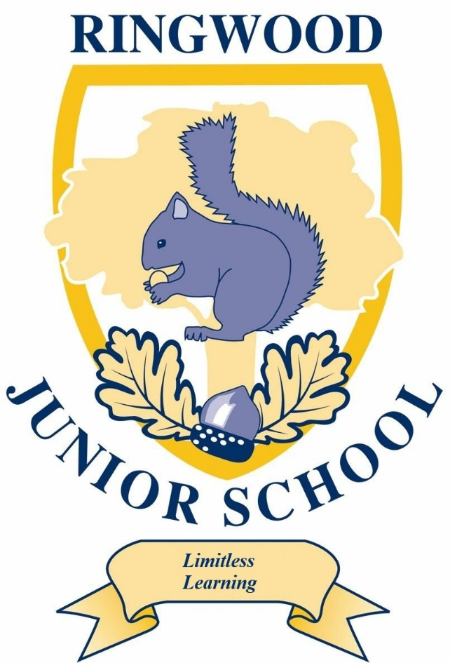

Name of school: Ringwood Junior School

Date of policy: October 2024

Members of staff responsible for PSHE Education: Mr L Dunningham

Line Manager (Member of SLT): Mrs S-A Evans

Review date: October 2027

PSHE Education Policy Guidance: overview and key

All schools are currently expected to provide PSHE education in their curriculum. This expectation has been strengthened from September 2020, when Relationships Education and Health Education aspects of the primary curriculum became compulsory in all schools. It’s vital that schools continue to cover the full breadth of PSHE education subjects that are outside the scope of the DfE’s statutory RSHE requirements so that wider life issues can be explored; these include economic education, environmental and community issues, rights and responsibilities.

SCARF provides a comprehensive scheme of work for PSHE education and covers all of the DfE's statutory requirements for Relationships Education and Health Education. It also covers the learning opportunities within the PSHE Association’s Programme of Study, therefore providing for elements such as the rights of the child, caring for the environment, economic education, and children’s social, moral, spiritual and cultural (SMSC) education, including British Values, which are statutory requirements.

- How this Policy was developed

This policy was written by Mr Lee Dunningham and developed in consultation with parents, teachers and other school staff, governors and the pupils at Ringwood Junior School. We have listened and responded to all views to help strengthen the policy, ensuring that it meets the needs of all of our pupils. It has been approved by the school’s governing body.

- Legal requirements of schools

It is now a statutory requirement for primary schools to deliver Relationships Education and the Department of Education (DfE) encourages schools to deliver Sex Education that ensures both boys and girls are prepared for the changes adolescence brings and – drawing on knowledge of the human life cycle set out in the National Curriculum for science – how a baby is conceived and born. We have created a separate RSE Policy which provides further detail regarding the statutory requirements and how it is taught at our school.

Health Education is also statutory in all schools.

We at Ringwood Junior School acknowledge that under the Education Act 2002/Academies Act 2010 all schools must provide a balanced and broadly-based curriculum and wish to have a policy that not only covers the statutory content but covers all aspects of our Personal, Social, Health Economic (PSHE) education provision.

- What Personal, Social, Health and Economic (PSHE) education including Relationships Education, is:

Our PSHE education, including statutory Relationships and Health education, and non-statutory sex education, as recommended by the DfE, provides a framework though which key skills, attributes and knowledge can be developed and applied. This promotes positive behaviour, good mental health and wellbeing, resilience and achievement, helping children to stay safe online, develop healthy and safe relationships, making sense of media messages, challenging extreme views and having the skills and attributes to negotiate and assert themselves now and in the future.

The school’s PSHE provision supports the school’s aims of developing confident citizens and successful learners who are creative, resourceful and able to identify and solve problems. The social and emotional development of pupils is embedded throughout the entire school’s curriculum and culture. The school has a powerful combination of a planned thematic PSHE program, built around a spiral curriculum of recurring themes, designed to:
  - Give pupils the knowledge and develop the self-esteem, confidence and self-awareness to make informed choices and decisions;
  - Encourage and support the development of social skills and social awareness;
  - Enable pupils to make sense of their own personal and social experiences;
  - Promote responsible attitudes towards the maintenance of good physical and mental health, supported by a safe and healthy lifestyle;
  - Enable effective interpersonal relationships and develop a caring attitude towards others;
  - Encourage a caring attitude towards and responsibility for the environment;
  - Help our pupils understand and manage their feelings, build resilience and be independent, curious problem solvers;
  - Understand how society works and the laws, rights and responsibilities involved.

We know there is a proven link between pupils' health and wellbeing, and their academic progress. Crucial skills and positive attitudes developed through comprehensive Personal, Social, Health and Economic education are critical to ensuring children are effective learners.

- How PSHE education, including Relationships Education, is provided and who is responsible for this

At Ringwood Junior School school we use SCARF, a comprehensive scheme of work for PSHE and Wellbeing education. An overview of SCARF can be found in our appendices. It covers all of the DfE's new statutory requirements for Relationships Education and Health Education, including non-statutory Sex Education, and the PSHE Association’s Programme of Study’s recommended learning opportunities, as well as contributing to different subject areas in the National Curriculum.
We follow the six suggested half termly units and adapt the scheme of work where necessary to meet the local circumstances of our school, for example, we may use our local environment as the starting point for aspects of our work. The school council are also consulted as part of our planning, to ensure pupil voice in considered and fed into the planned programme.
Our PSHE subject lead, Mr Lee Dunningham, works in conjunction with teaching staff in each year group (KS2) and is responsible for ensuring that all staff are equipped with the knowledge, skills and resources to deliver PSHE education confidently. Teachers can access a range of teaching support resources within SCARF, including guidance documents and teacher training films. Any teacher wanting further support should contact the PSHE subject lead in the first instance to discuss their training needs.
Class teachers follow the suggested six half termly units provided by SCARF for each year. Lessons are a weekly standalone PSHE lesson. The lesson plans list the specific learning objectives for each lesson and provide support for how to teach the lessons; class teachers and our PSHE lead often discuss this on an informal basis.
We have chosen SCARF as our PSHE resource because the lessons build upon children’s prior learning; we have assessed the content and feel that it is relevant and sensitive to the needs of the children. There is planned progression across the SCARF scheme of work, so that children are increasingly and appropriately challenged as they move up through the school. Assessment is completed by the class teacher using the SCARF Summative Assessment ‘I can…’ statements, alongside the lesson plan learning outcomes to demonstrate progression of both skills and knowledge.

- What is being taught

In the appendices can be found the SCARF medium term planning for both Key stage 1 and 2 and the Early Years Foundation Stage as well an overview of our Science programmes of study.

KS2
The SCARF programme divides the year into 6 themed units:
- Me and My Relationships: includes content on feelings, emotions, conflict resolution and friendships;
- Valuing Difference: a focus on respectful relationships and British values;
- Keeping Myself Safe: looking at keeping ourselves healthy and safe
- Rights and Responsibilities: learning about money, living the wider world and the environment;
- Being My Best: developing skills in keeping healthy, developing a growth mindset (resilience), goal-setting and achievement;
- Growing and Changing: finding out about the human body, the changes that take place from birth to old age and being safe.
Children are encouraged to engage in activities that promote an understanding of themselves as growing and changing individuals, and as members of a wider community, based on their own first-hand experiences. These activities also encourage pupils to understand how their choices and behaviours can affect others. They are encouraged to play and learn alongside – then collaboratively with – their peers. They may use their personal and social skills to develop or extend these activities. Children are also given the opportunity to make choices about their health and environment and are encouraged to develop a caring attitude towards others.
Within National Curriculum Science in Y2, the children learn that animals, including humans, have offspring that grow into adults. They should be introduced to the concepts of reproduction and growth, but not how reproduction occurs. In Y5, children are taught about the life cycles of humans and animals, including reproduction. They also learn about the changes that happen in humans from birth to old age. This includes learning what happens in puberty.
It is important that the transition phase before moving to secondary school supports pupils’ ongoing emotional and physical development effectively. The DfE recommends that all primary schools should have a sex education programme, tailored to the age and the physical and emotional maturity of the pupils. Within our non-statutory sex education that takes place in Y6 children will learn about how a baby is conceived, whether through sexual intercourse or IVF. This information builds on content they have previously learnt in the programme about relationships, puberty changes and reproduction; it lays the foundations for their ongoing Relationships and Sex Education in their secondary phase.

- How PSHE education, including Relationships Education, is taught
PSHE lessons are taught by their class teacher once a week in their timetabled PSHE lesson, throughout the whole year in their usual classes, in mixed sex groupings, using a range of interactive teaching methods, e.g. activity sheets, films, songs, online games, and drama techniques.
To ensure that children feel comfortable to learn about a range of topics, we create a safe learning environment using a group agreement at the beginning of lessons or topics. This includes a confidentiality statement understood by adults and children. The teachers will also use a range of skills, including distancing techniques and the anonymous question box. Teachers will answer children’s questions factually and honestly in an age appropriate way and respond to any disclosures following the schools safeguarding procedures/child protection policy which can be found within school and on our website

Support is provided to children experiencing difficulties on a one-to-one basis, Relevant leaflets, websites and posters can be found on display referring pupils to sources of help and advice, alongside suitable books which can be found in the library.

- How PSHE education is monitored, evaluated and assessed

We use three methods of monitoring and assessing learning within PSHE at Ringwood Junior School.

SCARF Progress
For each of the six units we carry out a specially designed pre- and post-unit assessment activity. Conducted twice, first at the beginning of the unit to determine where the children are at; and then again at the end of the unit, enabling us to monitor progress, record key points and identify areas for further development. This both teacher and child to see what progress has been made over the course of each half- termly unit of lesson plans.

SCARF Success
At the end of a unit we consider a range of ‘I can' statements, which summarise children’s learning against the unit's key learning outcomes.

Wearing my SCARF
This approach encourages children to reflect personally on their learning. They can record what they found helpful, thought-provoking, challenging and where their learning might take them to next. This also plays a key role in helping us to evaluate the programme.

This method of recording also enables the teacher to make an annual assessment of progress for each child, as part of the child’s annual report to parents. We pass this information on to the next teacher at the end of each year.
The monitoring of the standards of children’s work and of the quality of PSHE education is the responsibility of the PSHE subject lead. The work of the subject lead also involves supporting colleagues in the teaching of PSHE education and being informed about current developments in the subject.
The PSHE education subject lead has specially-allocated regular management time, enabling them to review evidence of the children’s work and monitor any assessments made.

- How the delivery of the content will be made accessible to all pupils

It is not our school’s policy to withdraw pupils with special educational needs from PSHE education to catch up on other national curriculum subjects: these aspects of personal and social development are as important to all pupils as their academic achievement, and contribute to it. Lesson plan content will be adapted and extra support provided where necessary to ensure all pupils are enabled to develop key skills, attributes and knowledge developed through the PSHE education programme. Work in PSHE takes into account the targets set for individual children in their Individual Education Plans (IEPs).

SCARF lesson plans are flexible and allow for teachers, who are skilled in adapting curriculum content to meet the needs of the children in their class, to adjust their content in order to meet the learning outcomes.

Our school ensures that the Relationships and Sex Education (RSE) elements of the PSHE education programme are relevant to all pupils; whatever their gender identity. All pupils learn together about all the changes that someone may experience as they go through puberty to help develop empathy and understanding and to reduce incidences of teasing or stigma. This will also ensure any child that identifies as transgender will have access to RSE that is relevant to the puberty they are likely to experience.

Our school acknowledges different ethnic, religious and cultural attitudes, as well as recognising that pupils may come from a variety of family situations and home backgrounds. These different families are acknowledged through our teaching and the use of resources that promote diversity and inclusion in Relationships Education.

Research shows that, on average, about 4% of pupils will go on to define themselves as gay, lesbian, bi-sexual or pansexual (GLBP). It is possible that some pupils will also have GLBP parents/carers, brothers or sisters, other family members and/or friends. Our PSHE education acknowledges this through scenarios, in a sensitive, honest and balanced consideration of sexuality. This helps create a safe environment for all pupils and staff. The public sector equality duty, created under the Equality Act, requires schools and other public authorities to eliminate discrimination and to advance equality in its everyday business, in the design of its policies and curriculum. Schools have a legal responsibility for eliminating discrimination; to do this, schools are required to raise pupils’ awareness of diversity and promote respectful relationships with those who are different from them.

Please request to see the school’s policy on anti-bullying, equality, diversity and inclusion for further information..

- Parental concerns and withdrawal of students

Parents have the right to request that their child be withdrawn from some or all of the non-statutory Sex Education our school teaches but not Relationships Education. They do not have a right to withdraw their children from those aspects of Sex Education that are taught in the statutory National Curriculum Science and Health Education. Parents are invited to view our resources and discuss any concerns with our staff.

Before granting a request to withdraw a child/ren, the head teacher will invite the parent to discuss the request with them to ensure that their wishes are understood and to clarify the nature and purpose of the curriculum. The head teacher will discuss with the parent the benefits of receiving this important education and any detrimental effects that withdrawal might have on their child. This could include any social and emotional effects of being excluded, as well as the likelihood of the child hearing their peers’ version of what was said in the classes, rather than what was directly said by the teacher (although the detrimental effects may be mitigated if the parent proposes to deliver sex education to their child at home instead). The school is responsible for ensuring that should a child be withdrawn, they receive appropriate, purposeful education during the period of withdrawal.

Parents should be given every opportunity to understand the purpose and content of Relationships Education and Sex Education. Good communication and opportunities for parents to understand and ask questions about our school’s approach help increase confidence in the curriculum.

It is statutory for our school to show parents examples of the resources we plan to use. We will provide opportunities for parents to view examples through class/year group meetings either face to face or virtually. Ongoing communication with parents about what is planned to be taught and when, will be provided through termly letters home. We advise parents to view the resources in order to support them in carrying out their responsibilities relating to providing RSE at home. It is valuable for a child’s development to learn about its own families values in regards to relationships and sex alongside the information they receive at school.

- Dissemination of the Policy

This policy has been made accessible to parents, teachers and other school staff, governors through the school website. Anyone wanting a printed copy or the policy to be provided in another language or format, should make a request to the school office. Should the policy be required in other languages, please contact the school office.

Should further information about PSHE education be required, please contact the PSHE education lead.

- Policy Review and Development Plan

The policy will be reviewed every three years, in consultation with parents, teachers and other school staff, governors and pupils.

- Sources of Further Information
This policy has drawn on:
- Relationships Education, Relationships and Sex Education (RSE) and Health Education Guidance, Department for Education (July 2019)
- Creating a PSHE education policy for your school, The PSHE Association (September 2018)
- Sex and Relationships Education (SRE) for the 21st Century, Brook, Sex Education Forum and PSHE Association - Supplementary advice to the Sex and Relationship Education Guidance DfEE (0116/2000) (2011)

This policy should be read in conjunction with the following:
- School’s own Safeguarding/Child Protection policy (inc. responding to disclosures)
- School’s own Confidentiality policy
- School’s own Anti-bullying policy
- School’s own Equality, diversity and inclusion policy
- DfE ‘Keeping children safe in education’ (2019)

Useful resources/Appendix
SCARF – policy and planning: templates, guidance, curriculum mapping and assessment tools (available online).

Coram Life Education Online Teaching and Learning Training Film Clips and RSE Guidance Document: supports schools in organising and delivering RSE with confidence. Available as part of the SCARF online comprehensive Relationships Education and Health Education curriculum resources:
https://www.coramlifeeducation.org.uk/scarf/lesson-plans/relationships-education--teacher-resources-guidance-documents-and-training-films (password protected).

PSHE Association PSHE Policy Guidance
https://www.pshe-association.org.uk/curriculum-and-resources/resources/creating-pshe-education-policy-your-school (members only)

The Sex Education Forum RSE Policy Guidance
https://www.sexeducationforum.org.uk/resources/advice-guidance/sre-policy-guidance

The Sex Education Forum have also provided a free resource to assist you in consulting pupils, parents and staff to inform you about what changes need to be made to your RSE policy and practice. ‘Activities for consulting about your school sex and relationships policy’.
https://www.sexeducationforum.org.uk/sites/default/files/field/attachment/Consultation%20activities%20-%20SRE%20policy%20-%20Sept%202014.pdf

The PSHE Association assessment guides for key stage 1-2 explain how PSHE teachers can use an ipsative model of assessment in PSHE education, and describe a wide range of methods available to assess progress, with accompanying examples from real classrooms.
https://www.pshe-association.org.uk/system/files/Primary%20assessment%20guide.pdf

SCARF medium term planning documents https://www.coramlifeeducation.org.uk/scarf/lesson-plans/policy-and-planning
Relationships and Sex Education can also be found within National Curriculum Science

